**MONOSTABLE MULTIVIBRATOR USING IC555**

**Exp No: 10 Date: 25/4/2022**

**Objective:**

**To design, simulate and verify Monostable multivibrator using IC555.**

**Software Required:**

LT SPICE - XVII

**Theory:**

Monostable Multivibrators have only ONE stable state (hence their name: “Mono”), and produce a single output pulse when it is triggered externally. Monostable Multivibrators only return back to their first original and stable state after a period of time determined by the time constant of the RC coupled circuit.

Consider the MOSFET circuit on the left. The resistor R and capacitor C form an RC timing circuit. The N-channel enhancement mode MOSFET is switched “ON” due to the voltage across the capacitor with the drain connected LED also “ON”.

When the switch is closed the capacitor is short circuited and therefore discharges while at the same time the gate of the MOSFET is shorted to ground. The MOSFET and therefore the LED are both switched “OFF”. While the switch is closed the circuit will always be “OFF” and in its “unstable state”.

When the switch is opened, the fully discharged capacitor starts to charge up through the resistor, R at a rate determined by the RC time constant of the resistor-capacitor network. Once the capacitors charging voltage reaches the lower threshold voltage level of the MOSFETs gate, the MOSFET switches “ON” and illuminates the LED returning the circuit back to its stable state.

Then the application of the switch causes the circuit to enter its unstable state, while the time constant of the RC network returns it back to its stable state after a pre-set timing period thereby producing a very simple “one-shot” or Monostable Multivibrator MOSFET circuit.

Monostable Multivibrators or “One-Shot Multivibrators” as they are also called, are used to generate a single output pulse of a specified width, either “HIGH” or “LOW” when a suitable external trigger signal or pulse T is applied. This trigger signal initiates a timing cycle which causes the output of the monostable to change its state at the start of the timing cycle and will remain in this second state.

The timing cycle of the monostable is determined by the time constant of the timing capacitor, CT and the resistor, RT until it resets or returns itself back to its original (stable) state. The monostable multivibrator will then remain in this original stable state indefinitely until another input pulse or trigger signal is received.

Then, Monostable Multivibrators have only ONE stable state and go through a full cycle in response to a single triggering input pulse.

Monostable Multivibrator Circuit: -

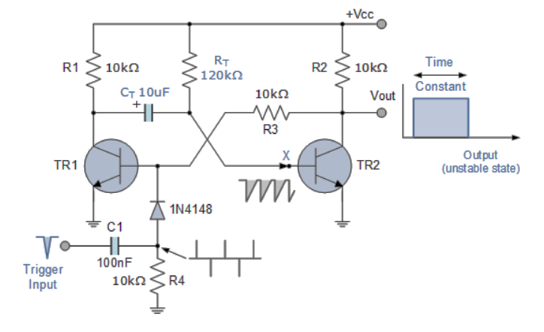

The basic collector-coupled transistor Monostable Multivibrator circuit and its associated waveforms are shown above. When power is firstly applied, the base of transistor TR2 is connected to VCC via the biasing resistor, RT thereby turning the transistor “fully-ON” and into saturation and at the same time turning TR1 “OFF” in the process. This then represents the circuits “Stable State” with zero output. The current flowing into the saturated base terminal of TR2 will therefore be equal to IB = (VCC – 0.7)/RT.

If a negative trigger pulse is now applied at the input, the fast-decaying edge of the pulse will pass straight through capacitor, C1 to the base of transistor, TR1 via the blocking diode turning it “ON”. The collector of TR1 which was previously at VCC drops quickly to below zero volts effectively giving capacitor CT a reverse charge of -0.7v across its plates. This action results in transistor TR2 now having a minus base voltage at point X holding the transistor fully “OFF”. This then represents the circuits second state, the “Unstable State” with an output voltage equal to VCC.

Timing capacitor, CT begins to discharge this -0.7v through the timing resistor RT, attempting to charge up to the supply voltage VCC. This negative voltage at the base of transistor TR2 begins to decrease gradually at a rate determined by the time constant of the RT CT combination.

As the base voltage of TR2 increases back up to Vcc, the transistor begins to conduct and doing so turns “OFF” again transistor TR1 which results in the monostable multivibrator automatically returning back to its original stable state awaiting a second negative trigger pulse to restart the process once again.

Monostable Multivibrators can produce a very short pulse or a much longer rectangular shaped waveform whose leading edge rises in time with the externally applied trigger pulse and whose trailing edge is dependent upon the RC time constant of the feedback components used. This RC time constant may be varied with time to produce a series of pulses which have a controlled fixed time delay in relation to the original trigger pulse as shown below.

Monostable Multivibrator Waveforms: -

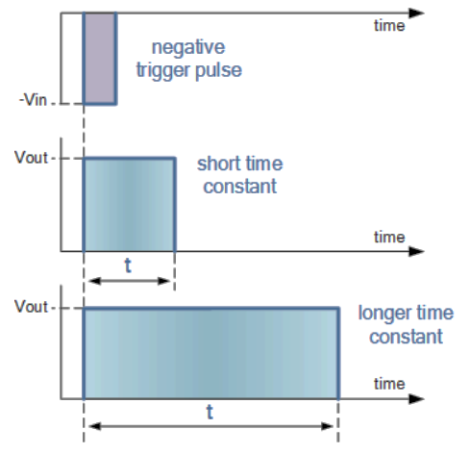

The time constant of Monostable Multivibrators can be changed by varying the values of the capacitor, CT the resistor, RT or both. Monostable multivibrators are generally used to increase the width of a pulse or to produce a time delay within a circuit as the frequency of the output signal is always the same as that for the trigger pulse input, the only difference is the pulse width.

**Procedure: -**

1. **Open LT Spice and click on new schematic to start the circuit making.**
2. **Components needed are: wires, ground, resistor, op-amp and voltage sources.**
3. **Place them all in the required way as per the requirement of circuit analysis.**
4. **Perform required analysis like transient or ac etc. (simulation commands)**
5. **Run the schematic once the circuit is complete**
6. **Click above the ac input voltage source for the input signal**
7. **Click above the load resistor to obtain the output signal.**
8. **Analyse the input and output obtained from the circuit analysis on LT Spice.**
9. **Save the schematic and continue further analysis if required.**

MONOSTABLE MULTIBIBRATOR: -

CIRCUIT: -

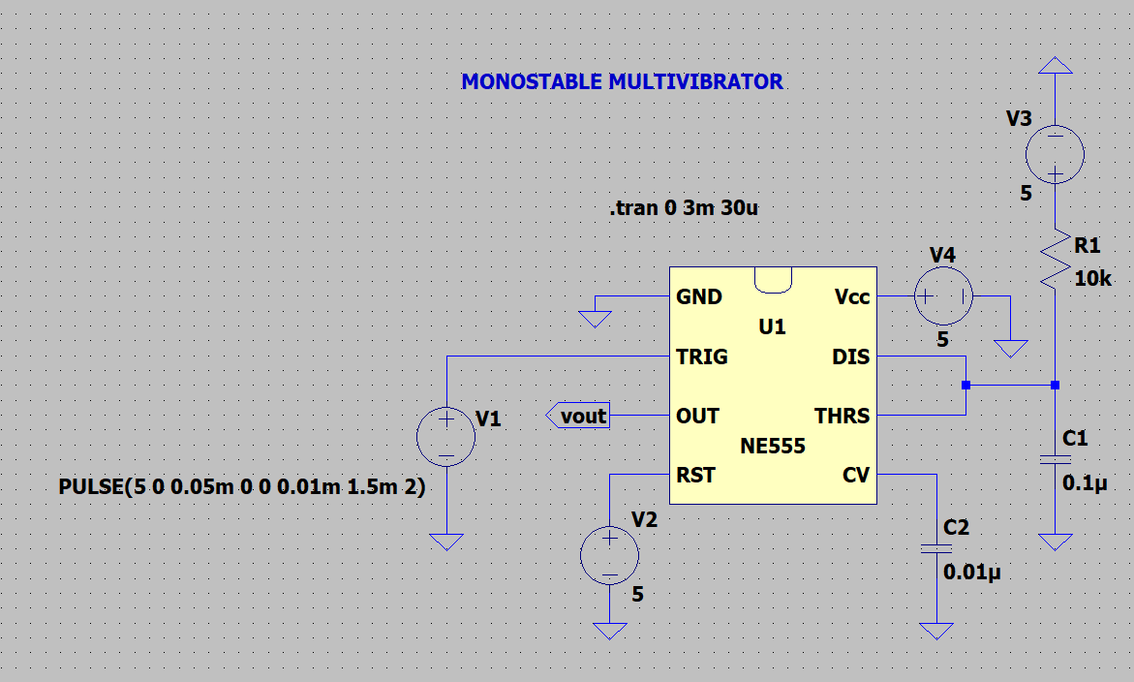

OUTPUT:

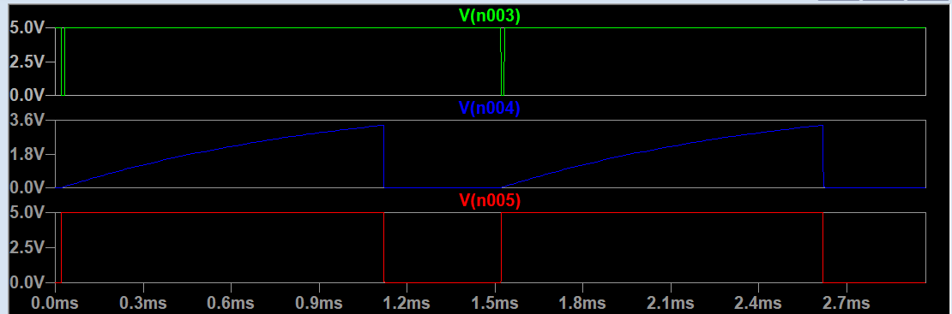

**RESULT: -**

**Thus, Monostable Multivibrator using IC555 is designed, tested and verified using LTSPICE.**